- Step-1:
F = 14 * scale
Scale varies from 0 to 5 according to character of Complexity Adjustment Factor (CAF). Below table shows scale:
0 - No Influence
1 - Incidental
2 - Moderate
3 - Average
4 - Significant
5 - Essential
- Step-2: Calculate Complexity Adjustment Factor (CAF).
CAF = 0.65 + (0.01 * F)
- Step-3: Calculate Unadjusted Function Point (UFP). TABLE (Required)
Function Units | Low | Avg | High
EI | 3 | 4 | 6
EO | 4 | 5 | 7
EQ | 3 | 4 | 6
ILF | 7 | 10 | 15
EIF | 5 | 7 | 10
Multiply each individual function point to corresponding values in TABLE.
- Step-4: Calculate Function Point.
FP = UFP * CAF

Example:
Given the following values, compute function point when all complexity adjustment factor (CAF) and weighting factors are average.

User Input = 50
User Output = 40
User Inquiries = 35
User Files = 6
External Interface = 4
Explanation:

- Step-1: As complexity adjustment factor is average (given in question), hence,

scale = 3.
F = 14 * 3 = 42

- Step-2:

CAF = 0.65 + ( 0.01 * 42 ) = 1.07

- Step-3: As weighting factors are also average (given in question) hence we will multiply each individual function point to corresponding values in

TABLE.

UFP = (50*4) + (40*5) + (35*4) + (6*10) + (4*7) = 628

- Step-4:
Function Point = 628 * 1.07 = 671.96

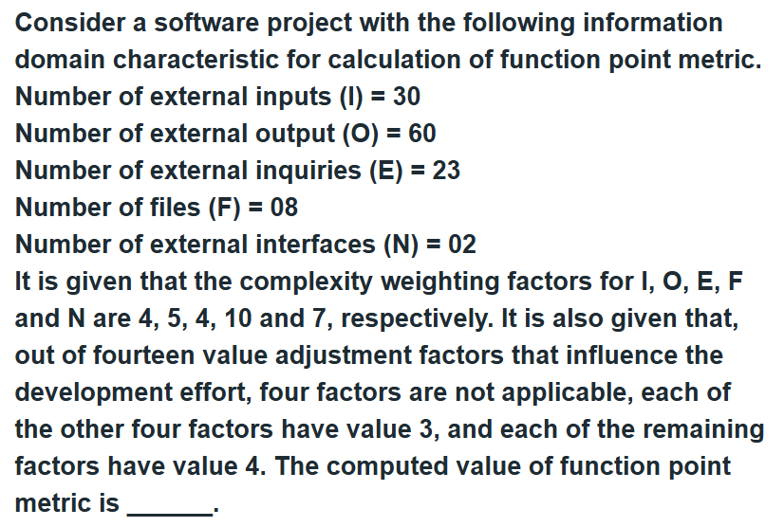

#include <bits/stdc++.h>
using namespace std;

// Function to calculate Function Point
void calfp(int frates[][3], int fac_rate)
{

// Function Units
string funUnits[5] = {
"External Inputs",
"External Outputs",
"External Inquiries",
"Internal Logical Files",
"External Interface Files"
};

// Weight Rates
string wtRates[3] = { "Low", "Average", "High" };

// Weight Factors
int wtFactors[5][3] = {
{ 3, 4, 6 },
{ 4, 5, 7 },
{ 3, 4, 6 },
{ 7, 10, 15 },
{ 5, 7, 10 },
};

int UFP = 0;

// Calculating UFP (Unadjusted Function Point)
for (int i = 0; i < 5; i++) {

for (int j = 0; j < 3; j++) {

int freq = frates[i][j];

UFP += freq * wtFactors[i][j];
}
}

// 14 factors
string aspects[14] = {
"reliable backup and recovery required ?",
"data communication required ?",
"are there distributed processing functions ?",
"is performance critical ?",
"will the system run in an existing heavily utilized operational environment ?",
"on line data entry required ?",
"does the on line data entry require the input transaction to be built over multiple screens or operations ?",
"are the master files updated on line ?",
"is the inputs, outputs, files or inquiries complex ?",
"is the internal processing complex ?",
"is the code designed to be reusable ?",
"are the conversion and installation included in the design ?",
"is the system designed for multiple installations in different organizations ?",
"is the application designed to facilitate change and ease of use by the user ?"
};

/*
Rate Scale of Factors
Rate the following aspects on a scale of 0-5 :-
0 - No influence
1 - Incidental
2 - Moderate
3 - Average
4 - Significant
5 - Essential
*/

int sumF = 0;

// Taking Input of factors rate
for (int i = 0; i < 14; i++) {

int rate = fac_rate;

sumF += rate;
}

// Calculate CFP
double CAF = 0.65 + 0.01 * sumF;

// Calculate Function Point (FP)
double FP = UFP * CAF;

// Output Values
cout << "Function Point Analysis :-" << endl;

cout << "Unadjusted Function Points (UFP) : " << UFP << endl;

cout << "Complexity Adjustment Factor (CAF) : " << CAF << endl;

cout << "Function Points (FP) : " << FP << endl;
}

// driver function
int main()
{
int frates[5][3] = {
{ 0, 50, 0 },
{ 0, 40, 0 },
{ 0, 35, 0 },
{ 0, 6, 0 },
{ 0, 4, 0 }
};

int fac_rate = 3;

calfp(frates, fac_rate);

return 0;
}

